# Task C10.2.3

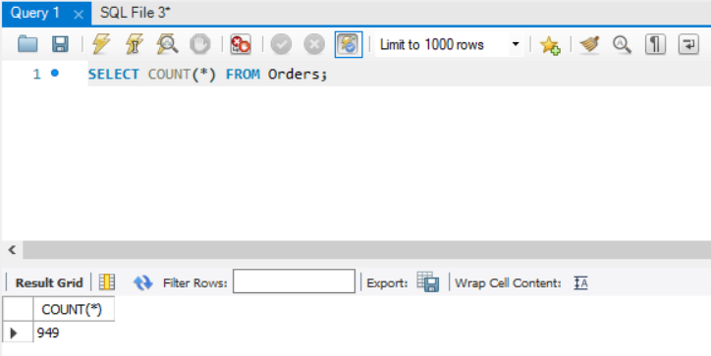

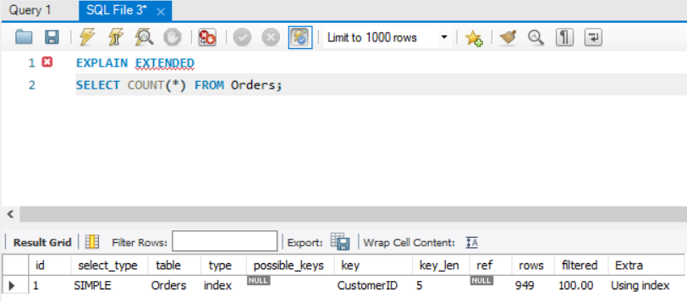

Database engine is using SIMPLE select_type which means it is performing UNION operation here on Orders table. Operation is getting performed on CustomerID column. To perform this calculation database engine needs to go through each row to perform this calculation that is why filtered is 100% in this case and that is very expansive process to execute.